Halleck Horticultural
 | CONTACT  Jill Mullaney  Halleck Horticultural, LLC  469.906.6074  jill@lesliehalleck.com  www.lesliehalleck.com |  | FOR IMMEDIATE RELEASE
Addicted to Plants? You might be a Plant Parent! A new book, Plant Parenting, teaches you step-by-step how to make more of the plants you love.

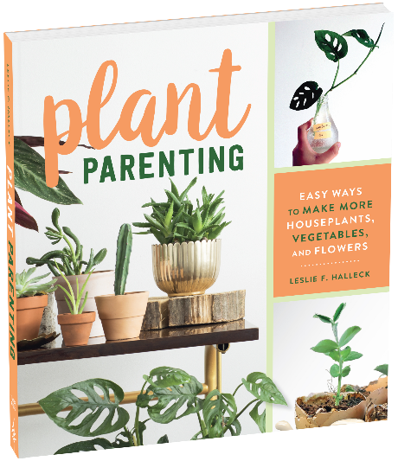
Press release

Dallas, TX – (4/8/2019) – Have you caught the plant keeping or gardening bug? Are you a plant addict who wants to stretch your plant-buying budget? Plant keeping is an ever-expanding trend whether you are a new plant enthusiast, a young gardener, or an experienced indoor and outdoor plant keeper who wants to learn new plant propagation techniques. Many gardeners want to grow their own foliage and food plants starts, expand indoor plant collections, or even propagate their own citrus plants. New houseplant keepers are eager to stuff their apartments with as many plants as they can find! Horticulturist & plant expert Leslie F. Halleck demystifies the art and science of plant propagation and plant parenting in her new book, Plant Parenting.
“This book is everything a plant parent needs to take their plant collection—and plant knowledge—to the next level.”—Maria Failla, Bloom & Grow Radio
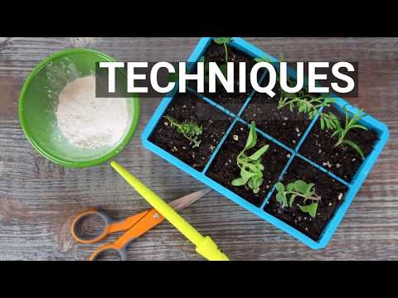
Plant Parenting: Easy Ways to Make More Houseplants, Vegetables, and Flowers is a highly-detailed, accessible guide for seed starters, plant collectors, indoor and outdoor gardeners, and anyone who wants to successfully propagate new plants. Halleck guides readers step-by-step with hundreds of beautiful photos. “Once you catch the plant bug, there is nothing more satisfying then learning to make more plants on your own – whether it’s foliage plants, succulents, or veggie seedlings” says Halleck.
Who will benefit from Plant Parenting? All plant-keepers interested in making more plants! From a new plant enthusiast, to a hobby gardener, to a city dweller, to a gardener on a budget, this book will help everyone learn the basics of plant propagation on the journey to becoming a full-fledged plant parent.
Plant Parenting details everything a gardener or hobbyist needs to know start or continue their plant parenting journey. Halleck begins by explaining the basics of plant reproduction and plant names, then details the materials and tools you need to succeed at plant propagation. Halleck then breaks down the how-tos of seed starting + saving, water rooting, and more involved vegetative propagation techniques. Plant Parenting wraps up with key tips on plant insects and diseases, and when and how to transplant your new plant babies into new containers or the garden.
“Lays out the steps to propagating your plants in a clear and engaging way. Whether you’re a seasoned gardener or a complete beginner, you’ll come away from this book inspired to try something new.”—Jane Perrone, host, On the Ledge podcast; former gardening editor, The Guardian
About the Author:
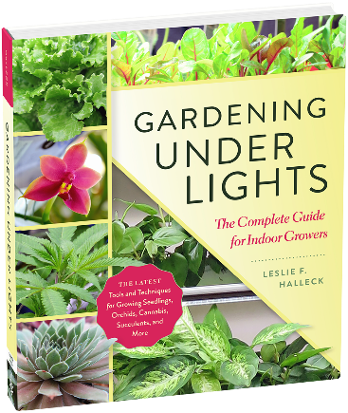
Leslie F. Halleck is a dedicated professional horticulturist and life-long gardener who is passionate about plants, gardening, and the horticulture industry. Leslie holds a M.S. in horticulture from Michigan State University, and a B.S. in Biology & Botany from The University of North Texas. She is a Certified Professional Horticulturist (CPH) via The American Society for Horticulture Science, with more than 25 years of green industry. Halleck is an award-winning writer for industry and consumer publications. She authored Gardening Under Lights; The Complete Guide for Indoor Growers in 2018. Her two books go hand-in-hand for anyone interested in indoor gardening. Halleck currently runs Halleck Horticultural, LLC, a Dallas, TX based consulting company. Visit her website and Plantgeek Chic blog here.
The official book release date is June 11th, 2019. Plant Parenting is available now for pre-order on Amazon (as well as other online book retailers) and will be released for shipping on Amazon on June 11^{th,} 2019.

###
CONTACT LESLIE: For more information, to schedule an interview or appearance with Leslie, or obtain more images or excerpts, or info about Leslie’s Plant Parenting Swap & Sip events, please contact Jill Mullaney, 469-906-6074 jill@lesliehalleck.com Mailing: 9540 Garland Rd. Ste. 381-342, Dallas, Texas 75218
TIMBER PRESS MEDIA CONTACT:
Katlynn Nicholls, 503-227-2878 ext. 141 knicolls@timberpress.com
Contact Katlynn for press opportunities related to the book, request a review copy of the book, book excerpts, or to host a giveaway with the book through your website or social media feeds. www.timberpress.com
- If you are a retailer purchase your books for resale through your Workman Publishing sales representative. If you are not a retailer but want to directly sell the book at your special event or appearance by Leslie, you can order books through Tina Parent tina.parent@storey.com in advance. ISBN-10: 1604698721 ISBN-13: 978-1604698725

